FLCD – Lab 3 – Documentation

Lung Alin-Sebastian

Gr. 934/2

ST Source code: <https://github.com/IcerOut/FLCD/releases/tag/Lab-2>

PIF Source code: <https://github.com/IcerOut/FLCD/releases/tag/Lab-3>

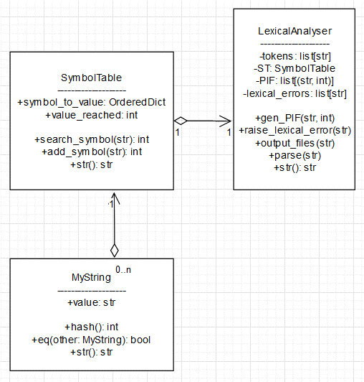

The LexicalAnalyser() class contains the list of tokens (read from token.in), a Symbol Table of type SymbolTable(), a PIF (a list) and a list of encountered lexical errors (a list).

When parsing, we open the program file and iterate through it line by line.

We remove all CR (\r) characters to simplify parsing.

Then we split the line into tokens using re.split(). For the pattern, we use '([ \t\n()\\[\\]{},;#\'\"])'

We basically split the string by each delimiter, but keep those delimiters in the tokens list as well (using regex capture groups)

Then we iterate through the tokens and clasify them as follows:

* If we are currently in a string constant and the token we encountered is not the string delimiter, we add it to the string constant we are building
* If we encounter a ‘#’, the rest of the line is a comment so we skip to the next line (So the content of the comments is ignored)
* If we encounter a single or double quote:
  + If we are not in a string constant, we start one
  + If we are in a string constant and it is the same character that started our current string, it means we just reached the end so we add the built string to the ST and PIF and then mark that we are no longer in a string constant
  + Otherwise, it’s a single quote inside of a double-quote string (or viceversa), so we just add it to the string we are building as normal
* If we encounter a space or tab, we skip it (and we do not add it to the PIF)
* If we encounter a newline (LN; ‘\n’):
  + If we are in a string constant, we raise a Lexical Error because it means the string was unfinished
  + Otherwise, we skip it (and do not add it to the PIF)
* If it’s in the token list, it means it’s a keyword, operator or separator, so we add it to the PIF with index 0
* If it mathches the pattern '^-?[1-9][0**-**9]+$' then it’s a numerical constant. This pattern should match all positive or negative whole numbers. We add it to the ST and the PIF
* If it matches the pattern '^[a**-**zA**-**Z][_a**-**zA**-**Z0**-**9]*$' then it’s an identifier. This pattern should match all sequences of letters, numbers or underscores that start with a letter. We add it to the ST and the PIF
* If it doesn’t match any of these branches, it’s an unexpected token so we raise a Lexical Error